Ground Effects
Specially-designed body side moldings enhance the exterior appearance of your Camaro. | 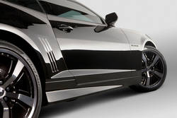  Image ID: 08_CHE_CAM_SPO_02
ACCESSORY NAME
PART NUMBER
DLR NET
STATUS
INSTALL TIME
Top of Form  For Use on Base Model Vehicles, Prime | 92207441 | $0.00 | Future Product | 3.00  Bottom of Form  Top of Form
For Use on SS Model Vehicles, Prime | 92208008 | $0.00 | Future Product | 3.00  Bottom of Form
Required and optional accessory equipment may vary depending on your vehicle. Prices shown are suggested manufacturer's retail price, not including applicable vehicle calibration, balancing, installation or taxes. Dealer final prices may vary. See your dealer for details.

