Performance Exhaust Upgrade Package
Constructed of T-304 stainless steel with free-flowing mandrel bent tubing. Features semi-polished muffler that meets all Federal decibel requirements. The system includes a welded-on exhaust tip and has an aggressive performance growl. | 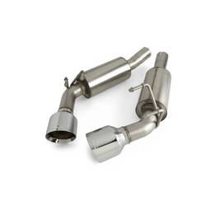  Image ID: 08_CHE_CAM_CAT_01_A
ACCESSORY NAME
PART NUMBER
DLR NET
STATUS
INSTALL TIME
Top of Form  L99 | 92206991 |  | Discontinued | 1.00  Bottom of Form  Top of Form
L99 | 92225671 |  | Discontinued | 1.00  Bottom of Form  Top of Form
V6 (LLT) Exhaust Upgrade Kit, No Tip | 92225673 |  | Future Product | 1.00  Bottom of Form  Top of Form
V6 (LLT) Exhaust Upgrade Kit, Round Tip | 92206990 |  | Future Product | 1.00  Bottom of Form  Top of Form
V8 (LS3 and L99) Exhaust Upgrade Kit, No Tip | 92225672 |  | Future Product | 1.00  Bottom of Form  Top of Form
V8 (LS3 and L99) Exhaust Upgrade Kit, Round Tip | 92206992 |  | Future Product | 1.00  Bottom of Form  Top of Form
V8 (LS3) Track Pack, Off-Road Use Only, Round Tip | 92231570 |  | Future Product | 1.00  Bottom of Form
Required and optional accessory equipment may vary depending on your vehicle. Prices shown are suggested manufacturer's retail price, not including applicable vehicle calibration, balancing, installation or taxes. Dealer final prices may vary. See your dealer for details.

