Service Information

Document ID: 2346049

#09-08-51-004: Information on Door and Quarter Panel Paint Appearance - (Sep 10, 2009)
Subject: | Information on Door and Quarter Panel Paint Appearance

Models: | 2010 Chevrolet Camaro

On the 2010 Camaro, the shade of paint on the doors may appear to be different than the shade of paint on the quarter panels. This appearance varies in severity based on different viewing angles and light conditions. This perception is more apparent with certain colors. Use this bulletin to help the customer understand the design of their vehicle.

Paint Process
At the time of vehicle manufacture, the complete sheet metal body of the car is painted at the same time (the body, hood, decklid and doors). The panels (doors, hood and decklid) are attached to the vehicle and in the proper position when it goes through the plant paint process. All of the panels receive the undercoat layers and top coat finishes using the same material, application process and final bake process. This continuity of process ensures a uniform paint application to the entire vehicle. The result of this extensive process is a seamless paint match over the entire vehicle. The only major exterior panels that do not get painted during this process are the bumper fascias. The bumper fascias receive a flexible paint application using a unique process. All of the paint used in the paint process is matched to a paint color standard, ensuring that the colors are consistent from batch to batch. This color standard also ensures consistency from vehicle to vehicle.

Vehicle Design
On the Camaro, the door to quarter panel angle match is the design intent. The geometry of the quarter panel provides a sporty definition and highlights the depth of the design. It is intended to show the color variation created by angling the body panels a few degrees.

Addressing Customer Concerns

Use the following photographs and descriptions to demonstrate to the vehicle owner that what they are seeing on their vehicle is not a color mis-match, but a intended design feature.
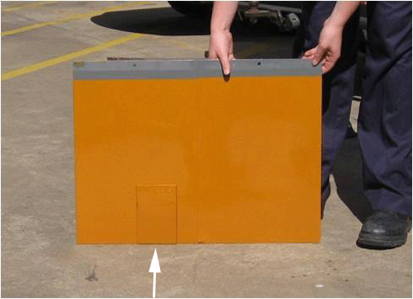
This first photograph shows a paint test panel finished in "Wildfire" metallic. The white arrow points to the paint "standard". This is the paint sample used to ensure color consistency.
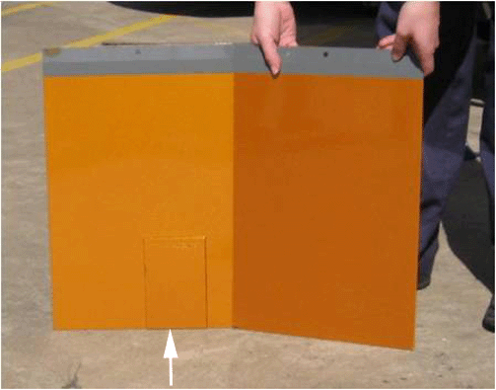
This photograph shows the same paint test panel with a slight crease in the center, creating an angle in the panel similar to the Camaro door to quarter panel relationship. The finish on the right side of the panel has "shifted", creating a different hue of the same color. Note the arrow shows the paint standard on the left side of the paint test panel in the same position as the first photograph.
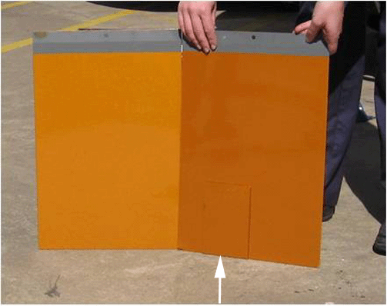
This final photograph shows the same paint test panel described in the second photograph. In this photograph, the arrow points to the same paint "standard" used in the first two photographs but it has been repositioned to the right side of the paint test panel. Note the paint "standard" has shifted along with the finish on the paint test panel.
GM bulletins are intended for use by professional technicians, NOT a "do-it-yourselfer". They are written to inform these technicians of conditions that may occur on some vehicles, or to provide information that could assist in the proper service of a vehicle. Properly trained technicians have the equipment, tools, safety instructions, and know-how to do a job properly and safely. If a condition is described, DO NOT assume that the bulletin applies to your vehicle, or that your vehicle will have that condition. See your GM dealer for information on whether your vehicle may benefit from the information. |  | WE SUPPORT VOLUNTARY TECHNICIAN CERTIFICATION
© 2009 General Motors Corporation. All rights reserved.

